1. [20 points] Describe/discuss/explain the mechanism(s) by which oxygen is transported from alveoli to cells (in tissue).

In normal circumstances alveolar partial pressure PAO2 ≈ 100 mmHg and the O2 in the blood coming back from the tissue to the pulmonary capillary has a partial pressure PO2 ≈ 40 mm Hg so there is a pressure gradient for oxygen to diffuse across the tissue barrier from the alveolus space into the pulmonary blood. A very small amount of oxygen is dissolved: for each mm Hg of PO2, there is 0.003 ml O2.100 ml-1 of blood, and most of O2 binds to hemoglobin to form oxyhemoglobin: HbO2. O2 is then carried over by the blood which becomes part of the systemic circulation and ends up at the tissue capillaries. Because mitochondria of the cells are utilizing oxygen, there is a pressure drive from the erythrocyte to the plasma to the interstitial fluid to the cell so oxygen goes down the pressure gradient and diffuses into the cells: O2 comes off hemoglobin as dissolved O2, diffuses off the red blood cell into the plasma and from the plasma into the interstitial fluid to be consumed in cell mitochondria.

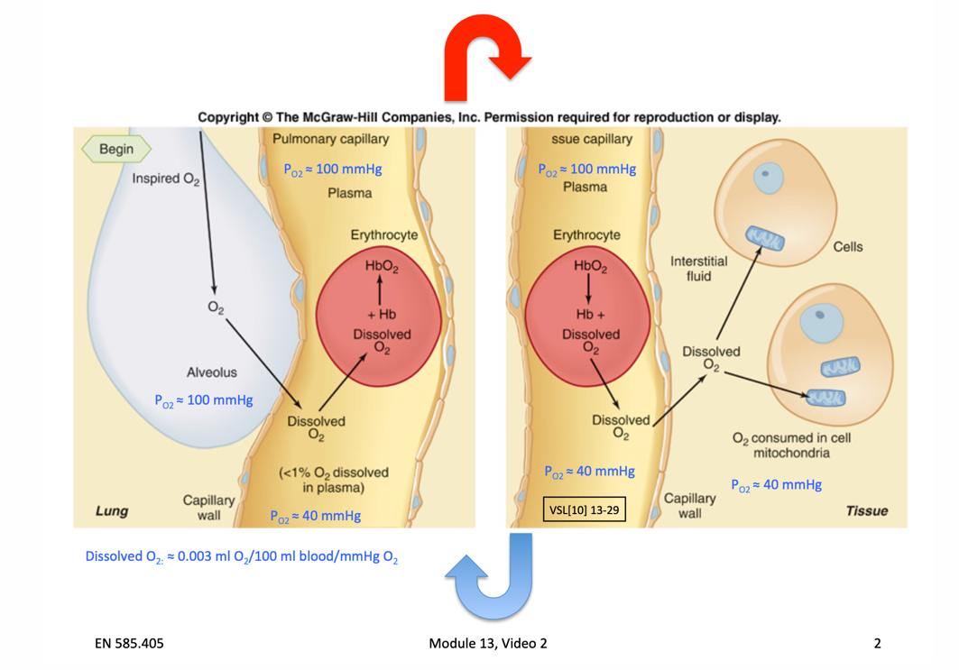

Figure 1

1. [20 points] Describe/discuss/explain the mechanism(s) by which carbon dioxide is transported from cells (in tissue) to alveoli.

Cells produce CO2 and there is a pressure gradient to drive CO2 to diffuse from the cells to the interstitial fluid and to diffuse across the tissue barrier into the blood plasma (PCO2 ≈ 46 mm Hg in the interstitial fluid, tissue capillary PCO2 ≈ 40 mm Hg). CO2 is carried into the blood in three forms:

* *dissolved* in the plasma or the red blood cell
* *bicarbonate* HCO3- which is formed by the following sequence:

CO2 + H2O → H2CO3 → H+ + HCO3-

The first reaction is slow in the plasma but fast within the red blood cell because of the presence of the carbonic anhydrase (CA). HCO3- diffuses into the plasma and to maintain charge balance a chloride ion moves in (chloride shift).

* *carbamino compounds* which are formed by the combination of CO2 with proteins, the most important being the amino groups of hemoglobin to form carbaminohemoglobin (for simplicity noted HbCO2)

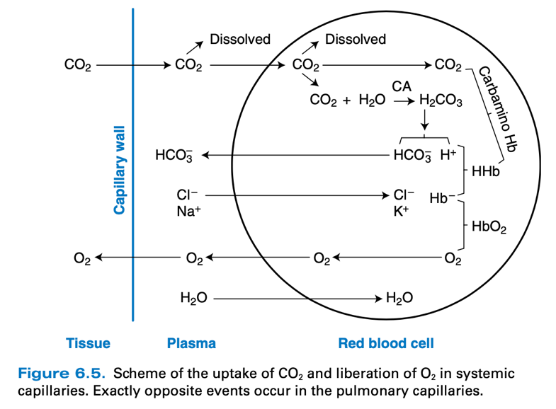

Figure 2, West[10] p.94

Among the three forms just described, under which carbon dioxide is transported from the cells to the lung, the predominant mechanism is in the form of bicarbonate HCO3-. When the blood enters the pulmonary capillary the PCO2 ≈ 46 mm Hg and the PCO2 in the alveolus is about 40 mmHg, the pressure gradient drives CO2 off the pulmonary capillary: the reverse reactions previously described happen, HCO3- and H+ combine to produce H2CO3, which then dissociates to CO2 and H2O, also HbCO2 generates Hb and free CO2. Free CO2 diffuses then across the blood gas barrier into the alveolar air to be exhaled.

1. [20 points] Describe/discuss/explain the effect(s) of increased temperature and of increased acidity on the oxygen - hemoglobin saturation curve. Describe/ discuss/explain the physiologic significance of such effect(s).

As the blood moves from the pulmonary capillary to the tissues, temperature is increased because of the heat produced by tissue metabolism. The PCO2 is increased because of the CO2 entering the blood from the tissues which increases acidity or H+ concentration (or a decrease in pH). The more metabolically active a tissue, the greater its PCO2, H+ concentration, and temperature, so conditions are less favorable for hemoglobin to bind O2, and as it passes through the tissue capillaries, hemoglobin has a decreased affinity for oxygen.

Increased temperature decreases hemoglobin’s affinity for oxygen by altering its conformation. Carbon dioxide and H+ decrease hemoglobin’s affinity by combining with the globin portion of hemoglobin and altering the conformation of the hemoglobin molecule.

As a net result, less oxygen can bind to hemoglobin reducing hemoglobin saturation with O2, and the oxygen-hemoglobin saturation curve is shifted to the right by an increase in temperature or increase PCO2, or H+ concentration (figure 3).

“Therefore, hemoglobin gives up even more oxygen than it would have if the decreased tissue capillary PO2 had been the only operating factor.”

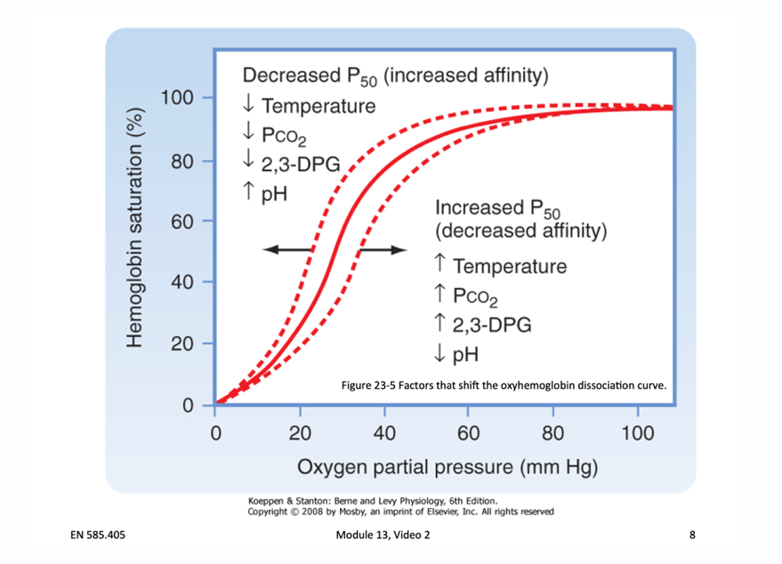

Figure 3

We gradually transitioned from one oxygen-hemoglobin saturation curve at PO2 ≈ 100 mm Hg, PCO2 ≈ 40 mmHg, about 100% O2 saturation of Hb at the pulmonary capillary toward, when reaching the tissue’s capillary, an oxygen – hemoglobin saturation curve corresponding to PCO2 ≈ 46 mmHg: hemoglobin releases more oxygen during passage through the tissue’s capillary providing cells additional oxygen (figure 4).

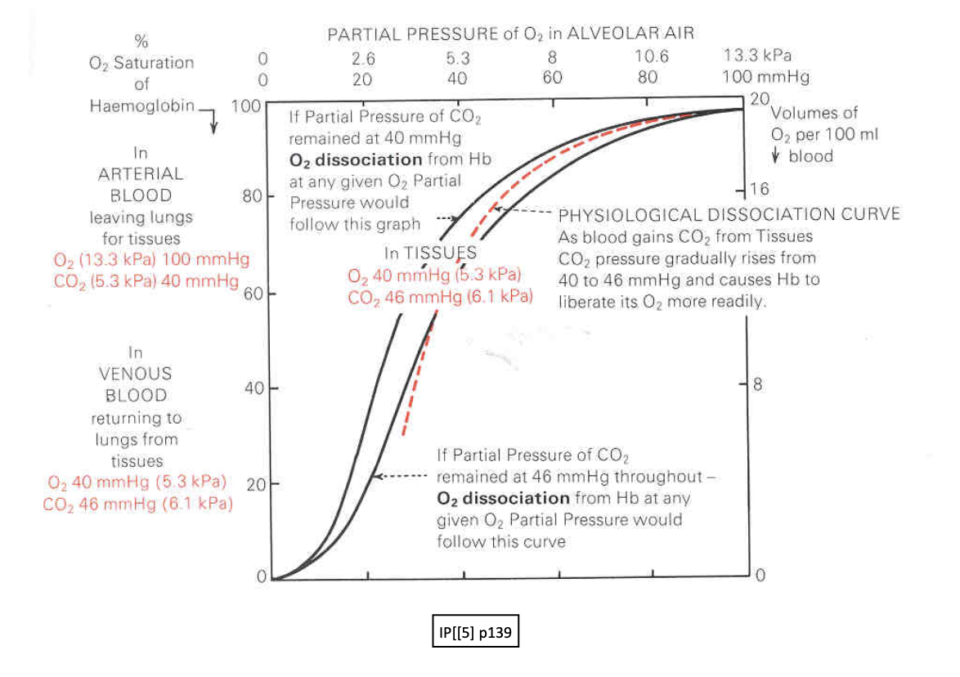

Figure 4